Autonomous Crash Avoidance System

by

Joshua Miller <mille21@calpoly.edu>

Brian Ujiie <bujiie@calpoly.edu>

Gordon Woods <woods@calpoly.edu>

Project Advisor: John Fabijanic, Ph.D.

Instructor’s Comments:

Instructor’s Grade: __________________________

Date: ­­­­­­­­­­­­­­_______________________

Autonomous Crash Avoidance System

by

Joshua Miller <jmille21@calpoly.edu>

Brian Ujiie <bujiie@calpoly.edu>

Gordon Woods <gwoods@calpoly.edu>

PICTURE GOES HERE

Mechanical Engineering Department

California Polytechnic State University

San Luis Obispo, CA 93405

June 2010

**Statement of Disclaimer**

This project was submitted in fulfillment of the Mechanical Engineering Department’s senior project requirement. Acceptance of this project does not imply technical accuracy or reliability. Any use of information found within this report is done at the risk of the user. These risks may include catastrophic failure of the device or infringement of patent or copyright laws. California Polytechnic State University at San Luis Obispo and its staff cannot be held liable for any use or misuse of the project.

Table of Contents

1.0 Introduction 7

2.0 Background Research 8

2.1 Path Planning Methods 8

2.1.1 Rapidly-exploring Random Tree Method 8

2.1.2 Artificial Neural Network Method 9

2.2 Current Systems Available 10

2.2.1 Mercedes Distronic Plus 10

2.2.2 Toyota Smart Stop Technology 10

2.2.3 Acura Collision Mitigation Braking System 11

2.2.4 Honda Advanced Safety Vehicles (ASV) 11

2.2.4 TASS PreScan Software 11

2.3 Sensors 12

2.3.1 Radio Detection and Ranging (RADAR) 12

2.3.2 Light Detection And Ranging (LiDAR) 12

2.3.3 Ultrasonic Sensor 13

2.3.4 Magnetic Sensor 13

2.3.5 Inertial Measurement Unit 13

2.3.6 Xiphos Board 14

2.3.7 Primary Computer 14

3.0 Project Objectives 15

3.1 General Design Constraints 15

4.0 Design Development 16

4.1 Selection of Path Planning Algorithm 16

4.1.1 RRT Pseudo-code 16

4.1.2 Pure Pursuit Path Follower 17

4.1.3 Proposed Software Diagram 17

4.2 Selection of Sensors 18

4.2.1 Simulated Sensors 18

4.2.2 Track-based Sensors 18

4.2.3 Vehicle-mounted Sensors 19

4.2.4 Sensor Position Selection 20

4.3 Selection of Obstacles 21

4.3.1 Stationary Obstacles 21

4.3.2 Moving Obstacles 22

4.4 Selection of Radio Controlled Car 22

4.5 Selection of the Test Track 23

5.0 Design Overview 24

5.1 Concept Components 24

6.0 Final Design 26

6.1.0 Description & Layout 26

6.2.0 UART Communication 27

6.2.1 UART Basics 27

6.2.2 UART Framing 28

6.3.0 R/C Truck Onboard Microcontroller 28

6.3.1 dsPIC33FJ64MC202 28

6.3.2 Quadrature Encoder Interface (QEI) 29

7.0 Analysis Results 30

8.0 Cost Breakdown 31

8.1.0 Materials, Geometry, Component Selection 31

6.0 Special Instructions 32

6.1 Hardware Protection 32

6.2 Vehicle Dynamics Modifications 32

6.3 Encoder Construction 32

6.4 Steering Wheel Interface 32

7.0 Repairs 33

7.1 Basic Vehicle Repairs 33

8.0 Preliminary Plans 34

8.1 Construction 34

8.1.1 Utility Pole 34

8.1.2 Pedestrian 34

8.1.3 Cross Traffic (Vehicle) 34

8.1.4 Rear End (Vehicle) 34

8.1.5 Remote Control Vehicle (Host Vehicle) 34

8.2 Testing 35

8.2.1 Utility Pole 35

8.2.2 Pedestrian 35

8.2.3 Cross Traffic (Vehicle) 35

8.2.4 Rear End (Vehicle) 35

8.2.5 Remote Control Vehicle (Host Vehicle) 35

9.0 Management Plan 36

9.1 Project Schedule 36

10.0 Work Cited 37

Appendix A: Quality Function Deployment 38

Appendix B: Test Plan 39

Appendix C: Parts List 40

Appendix D: Project Gantt Chart 41

Appendix E: Ultrasonic Sample Calculation 42

Appendix F: Xiphos Board 43

Appendix G: LV MaxSonar EZ2 44

Appendix H: WIZnet Gateway 45

Appendix I: Opto Photo Interrupter 46

Appendix J: Traxxas Slash Truck 47

Appendix K: 6 DOF IMU 48

# Introduction

In largely populated states such as California, vehicle accidents occur at an alarming rate. According to National Highway Traffic Safety Administration (NHTSA) in 2009 over 3,000 passenger and non-passenger vehicle fatalities were recorded in California alone, with over 4,000 vehicles involved in these accidents [1]. A study conducted by California’s Department of Motor Vehicles recorded over 31 million vehicles registered in California as of 2009 [2]. The integration of cell phones, iPods, and other distractive devices into vehicles decreases drivers’ attention from the road. Road hazards such as fallen trees, animals, pedestrians, and others can also cause accidents. The NHTSA has organized the Enhanced Safety of Vehicle competition in an effort to reduce the number of vehicle related fatalities by encouraging interest in traffic safety in engineering talent and by displaying innovative concepts created by international universities. The next competition is scheduled for June 2011.

Under the sponsorship of Professor Charles Birdsong, the goal of this project is to develop a proof of concept for the autonomous planning and maneuvering of vehicles in the accident situations. The scope of this proposal is limited to temporary, reactive maneuvers, attempting to avoid a collision or reduce its impact. It will not be capable of long distance navigation nor will it be able to completely supplant human drivers. However it should be able to take control of situations in which a driver is temporarily impaired or otherwise unable to respond to a road hazard, thereby minimizing or completely preventing human injury and improving general public safety. The proof of concept results will inform the National Highway Traffic Safety Administration and automotive manufacturers of the viability of such a security measure being implemented in all vehicles.

# 2.0 Background Research

The National Highway Traffic Safety Administration (NHTSA) is responsible for the Enhanced Safety of Vehicles (ESV) Conference held approximately every other year. This conference is an international gathering created to display advances in vehicle technologies from countries all around the world. The year 2011 marks the 22nd conference held with high expectations for cutting-edge technologies. In conjunction with the ESV 2011 Conference, this project aims to develop a working scale model as a proof of concept for a self-maneuvering crash avoidance system.

## 2.1 Path Planning Methods

### 2.1.1 Rapidly-exploring Random Tree Method

The Defense Advanced Research Projects Agency (DARPA) has produced prominent technologies through their Urban and Grand (desert) Challenges. Within each of these challenges, full-scale vehicles are required to navigate autonomously through a course of waypoints and obstacles. Of the competitors, the Massachusetts Institute of Technology (MIT) team was noted for their use of the Rapidly-exploring Random Tree (RRT) path planning method [3]. The RRT method begins by generating random branches from a start node (Figure 1). Each branch is compared with boundary conditions defined by obstacles in the driving plane. If a branch does not meet the boundary conditions, the branch is terminated. Branches that meet the boundary conditions become intermediate nodes. From these intermediate nodes, new random branches are produced and compared with the boundary conditions. This process continues until a viable path is found that reaches the target node [4].

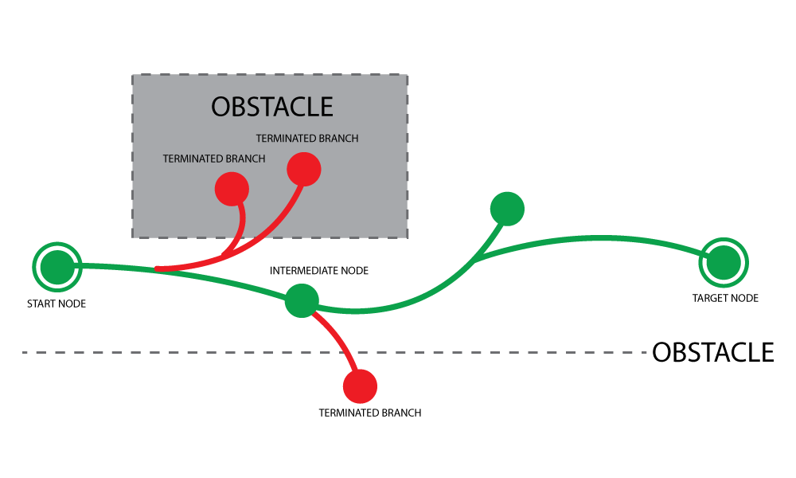

Figure 1. Rapidly-exploring Random Tree (RRT) nodes and branches mapping acceptable paths (green) and marking failed paths (red) in the driving plane.

In addition, MIT continued to monitor for collisions as their vehicle executed the feasible path. If interference occurred and all feasible paths were terminated, an emergency braking system was applied [4].

Applications of the RRT algorithm include robotic and video game motion planning. Use for intelligent robots aid scientific discoveries and are capable of traversing harsh environments with minimal harm to humans. The RRT algorithm allows robots to select safe travel paths to minimize damage and human intervention. In addition to robots, video game developers have embodied artificial intelligence methods into recent games. The RRT method has been used for complex scenarios, typically in three dimensional space situations. For example, RRT algorithms would plan physically capable jumping sequences for a character jumping from one building to the next.

Advantages to the RRT method include generalization in path planning and minimal configuration. The RRT algorithm creates random branches non-reliant on system stimulus. Therefore, the system generates potential paths regardless of its surroundings. The filtering of these paths is done with sensor-acquired boundary conditions. In addition, the RRT method does not require pre-configuration with respect to its host (vehicle dimensions, vehicle speed, etc.). Vehicle dynamics and environment data are tracked independently of path prediction.

Disadvantages of the RRT method include lag time in determining complex paths and lack of a memory. Complex paths through multiple obstacles will increase path-planning time using the RRT method. More random branches must be generated and assessed to determine a feasible path. In addition, the RRT method lacks a memory system. Planning time could be reduced if vehicle dynamics and environmental conditions matched a previous occurrence and path plan. However, without a memory system, the system must re-calculate a feasible path reducing reaction time.

### 2.1.2 Artificial Neural Network Method

An artificial neural network is designed to mimic the neurons found in the human brain on a much simpler scale [5]. The neural network receives environment input and applies a pre-taught weight to the values producing an acceptable output. For example, if the inputs to the network were a vehicle host speed of 50 miles per hour with a stationary obstacle 100 feet ahead, the artificial neurons would output a safe steering angle and braking force that could reduce or avoid collision. The weights applied to the input data are calibrated during the learning stage. The learning stage consists of controlled input and output example configurations [5]. By knowing the output of the examples, the systems teacher can adjust the network weights to produce similar results [5]. This calibration process continues until the networks weights undergo negligible change.

Large-scale neural networks consist of many inputs each weighted based on the learning stage. However, the large number of inputs from the environment introduces increased chances of decision error. Therefore, the hidden layer of neurons (Figure 2) provides additional weights to the data ensuring robust planning outputs [5]. Additional hidden layers can be added to the network.

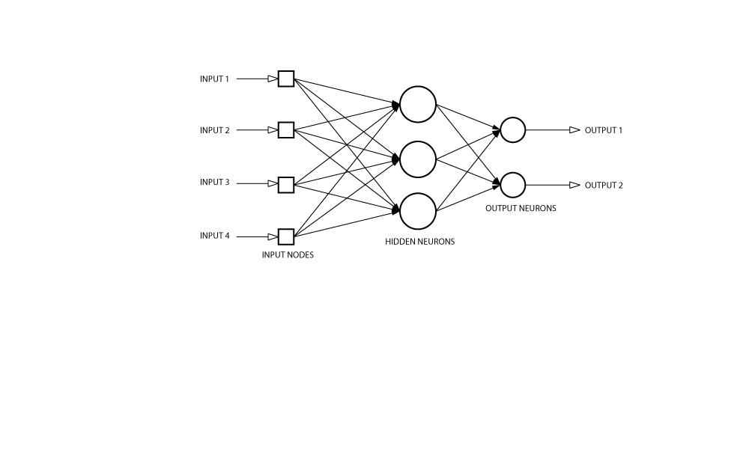

Figure . Artificial Neural Network (ANN) basic data flow diagram.

In a more sophisticated neural network, reinforcement learning can be applied. Instead of a teacher feeding examples into the system, the network learns through continual interaction with the environment [5]. The system does not go through a calibration phase of predetermined inputs and outputs. Instead, the system employs a delayed-reinforcement model that adjusts the network weights based on sensor input previously recorded. The delay protects the system from undesired outputs as it learns from the environmental data.

Applications of artificial neural networks are geotechnical engineering and atmospheric remote sensing. Geotechnical Engineers commonly use neural networks to estimate ground and soil properties [10]. The neural network provides predictions based on previously analyzed properties. In addition, MIT has used artificial neural networks to predict temperatures at various altitudes using other available properties [11].

Advantages to using an artificial network are its generalization to a wide spectrum of conditions and its protection from hazardous output. Although some form of learning is required, the neural network is capable of assessing a variety of conditions regardless of it being previously taught to the system. In addition, the weights and additional hidden layers provide protection from erroneous outputs. Additional hidden neural layers ensure robust predictions by the system. Furthermore, a neural network can be easily adapted to perform in specific environments by retraining the system and adjusting the weights.

Disadvantages to using the artificial network are its learning stage and focus on specified environments. A neural network requires a learning stage to ensure robust planning. The learning examples must be well moderated and taught to ensure network weights are accurate. During the learning process, vehicle dynamics are accounted for. Each vehicle may possess significant differences in vehicle dynamics requiring separate learning stages. Furthermore, examples taught to the neural network systems are limited to specific environments such as highway, not off-road terrain.

## 2.2 Current Systems Available

### 2.2.1 Mercedes Distronic Plus

Mercedes Benz equips their high-end model vehicles with Distronic Plus, a crash mitigation system. Distronic Plus uses RADAR-based technology to sense environment conditions and maintain safe driving distances [6]. If required, Distronic Plus can bring the vehicle to a complete stop. Recently, Distronic Plus has included new technology, PreSafe, allowing the system to sense imminent crashes and apply large braking forces to reduce impact in an accident. Distronic Plus has the capability of defining a driver selected following distance and maintaining set distance during leisure driving [6]. In addition, the system can apply up to 40 percent of the vehicles braking power to bring it to a complete stop (outside of PreSafe braking) [6].

### 2.2.2 Toyota Smart Stop Technology

Toyota has developed and employed Smart Stop Technology in their vehicles. Smart Stop monitors the vehicles pedal input by the driver and reduces the engines power if both pedals are pressed (under certain conditions) [7]. The system will intervene if the accelerator has been pressed first and the brakes have been pressed for more than one half second [7]. To account for vehicles starting on steep hills, the system will not engage if the brakes have been pressed first. According to Toyota, all new models will be equipped with Smart Stop Technology by the end of 2010.

### 2.2.3 Acura Collision Mitigation Braking System

Acura’s Collision Mitigation Braking System gives the driver advanced warning of a potential crash and applies a brake pressure to reduce collision forces. In addition to their braking system, Acura employs a 4-channel Vehicle Stability Assist (VSA®) that adjusts brake pressure and engine power to help driver control [8].

### 2.2.4 Honda Advanced Safety Vehicles (ASV)

Honda has been a major player in the vehicle safety technologies business. Honda proposes the use of vehicle-to-vehicle communication systems implemented in all motorized transportation off the production line. In rural areas, vehicles can communication with each other about their relative positions around blind turns and/or in poor visibility. In addition, vehicles can communicate with a control station located at busy intersections. This control center distributes information to all connected vehicles about the location of other cars, trucks, and motorcycles [19]. This communication with the control system provides an audible warning to the driver when another vehicle may not be seen. In addition to auditory warning, Honda’s ASV technology can provide a visual warning on integrated GPS devices and motorcycle displays [19].

### 2.2.4 TASS PreScan Software

PreScan is a software tool designed to test vehicle assistant systems without physical models [9]. The software includes virtualized system input that mimics environment data produced by a variety of sensors. PreScan allows users to custom build scenarios to fit testing applications of their system. In addition, PreScan allows users to test and verify algorithms used to process sensor data [9]. Furthermore, PreScan users are able to attach their physical systems central processing unit to verify the systems functionality through virtual scenarios [9].

## 2.3 Sensors

### 2.3.1 Radio Detection and Ranging (RADAR)

RADAR consists of a transmitter and a receiver. The transmitter sends out high-frequency radio pulses that are redirected by physical obstacles back to the receiver. The time delay between the pulse transmission and the pulse detection provides the necessary parameters to calculate position [12].

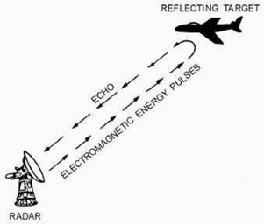

Figure 3. Basic RADAR implementation

Tyco Electronics manufactures RADAR sensors specific to crash avoidance technologies. Tyco Electronics claims their sensor can detect and track obstacles within short ranges—up to 30 meters—while maintaining a low cost design. These short-range sensors are capable of detecting obstacles within blind spots of a vehicle [13].

### 2.3.2 Light Detection And Ranging (LiDAR)

Similar to RADAR, LiDAR uses the time delay between transmitted and received pulses to calculate obstacle positions. Typically, LiDAR uses shorter wavelengths including ultraviolet, visible or infrared.

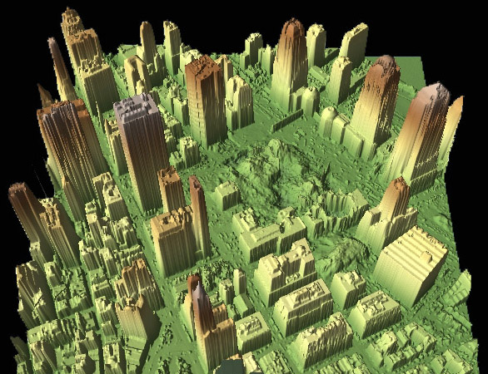

Figure 4. LiDAR mapping of Ground Zero in New York City

Velodyne, a manufacturer of LiDAR sensors boasts its compact size sitting 5.9 inches tall with a diameter of 3.4 inches. The total weight of the system is less than two kilograms [14]. The Velodyne LiDAR system is capable of 360 degree field of vision as well as a 40 degree vertical viewing range. The sensor is capable of taking 800,000 data points per second to create detailed environment maps (figure 4). The LiDAR system comes equip with a range of 5 centimeters to 100 meters [14]. Velodyne’s LiDAR sensor is built to produce data accurate to ±2 centimeters [14].

### 2.3.3 Ultrasonic Sensor

Ultrasonic sensors (figure 5) use the same method as RADAR and LiDAR. Ultrasonic uses sound waves to detect obstacles. The transmitter sends out sound waves—usually inaudible to humans—that bounce off objects and back to the receiver.

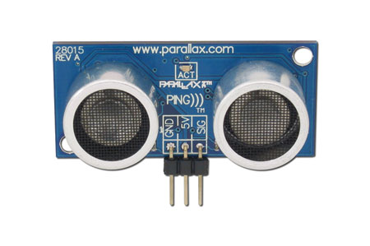

Figure 5. Hobbyist ultrasonic sensor

Ultrasonic sensors are compact and cheap. Ultrasonic sensors can have ranges from 0 to 6.25 meters with a blind spot from 0 to 0.15 meters [15]. Common problems with using multiple ultrasonic sensors are cross signal interference. If all sensors fire simultaneously, each receiver will pick up a combination of all transmitted signals resulting in inaccurate time delays. Therefore, Tyson Messori, a Cal Poly, San Luis Obispo Mechanical Engineering Graduate, suggested a tandem firing method. Each sensor is fired individually. Each sensor fires after the previous sensor has received its signal so that no two are firing at the same time. In addition, running the sensors at different frequencies reduces the cross sensor noise [16].

### 2.3.4 Magnetic Sensor

Magnetic sensors have been used in previous research under Professor Charles Birdsong. Research was conducted on truck crash avoidance systems—mainly tri-axle trucks and larger—to minimize blind spots for the driver. As a cheaper alternative to multiple RADAR sensors along a trucks cargo trailer, magnetic sensors were used. The magnetic sensors were capable of detecting metal objects—other vehicles—passing alongside the trailer. The sensors would display disturbances in the magnetic field, indicated a vehicle was present.

### 2.3.5 Inertial Measurement Unit

Inertial measurement units (IMU) are capable of detecting the dynamic properties of moving vehicles.  A typical six degree-of-freedom unit consists of three accelerometers—detects accelerations in the x, y, and z axis—and three gyros—detects roll, pitch, and yaw rates—based on the vehicles current dynamic state. Since the IMU will determine the acceleration and rate of spin of an object, it is possible to determine the vehicle’s position and speed if the initial conditions are known.  Many IMU’s are available with built in microcontrollers that can smooth and filter the data prior to being sent to the computer.

### 2.3.6 Xiphos Board

The Xiphos board is built and designed by Cal Poly’s alumni Darron Baida as a senior project and addition to the Robotics Club. The Xiphos Board contains a 16 MHz primary clock, I2C and RS232 communication capability, 8 analog pins, 10 digital pins, and is Xbee (radio frequency) capable. The Xiphos Board has additional features that exceed the scope of this project.  However, should the project continue and require upgrades and design modifications, the Xiphos Board contains a wide spectrum of capabilities to facilitate redesign and additional hardware.

### 2.3.7 Primary Computer

The primary computer for this project has been provided by Professor Charles Birdsong. The computer was built as a data acquisition system and contains 3 serial, 7 USB, and 3 firewire ports. Currently, the computer is fitted with Microsoft Windows XP 32bit operating system and a sponsored installation of PreScan by TASS-Safe.

# 3.0 Project Objectives

## 3.1 General Design Constraints

This project reaches a variety of target customers. First, Professor Charles Birdsong has put much effort into crash avoidance technology research and continues to sponsor students who find interest in the subject. Second, the ESV Conference Committee along with the rest of the NHTSA encourage universities to increase student involvement in quality of life research. Lastly, the vehicle consumer market can potentially benefit in a profound way, from crash avoidance technologies developed by college students. Quality of life and safety can be increased with smarter cars capable of detecting and reducing crash injuries. The specific goal for this project is to create a system that can briefly take control of a vehicle and steer it out of harm’s way, returning control to the driver once the danger has passed.

The objective of this project is to develop a proof of concept showcasing the potential of autonomous crash avoidance systems. We intend to create a scale model that will replicate hazardous scenarios.  This model will consist of a remotely controlled vehicle that will utilize software we develop to interpret sensor data and execute evasive maneuvers if necessary. Table 3.0.1 summarizes the general specifications we determined for this project.

Table 3.0.1. Generalized prototype specifications

|  |  |  |  |  |  |
| --- | --- | --- | --- | --- | --- |
| **Spec. #** | **Parameter** | **Requirement** | **Tolerance** | **Risk** | **Compliance** |
| 1 | Weight | 100 lb | Max | M | I |
| 2 | Track Size | 15 ft | Max | M | I |
| 3 | Budget | $2,000 | Max | L | A, I |
| 4 | Model Car Size | 1/10th scale | Max | L | A, I |

Because this project is being undertaken for a competition, portability for transportation is a necessary consideration.  Weight and size will impact the cost of shipping. Therefore, we plan to minimize the size of our prototype to keep it within the standard shipping capacities of conventional postal services.

The R/C vehicles that were readily available to us determined the scale of our project. However, because we cannot scale down the sensors, it needs to be large enough to be capable of supporting the sensors we select. Therefore, we determined that a 1/10th scale model would be appropriate.

To determine the clearance we wanted to maintain between the vehicle and road hazards, we researched standard road lane design. The average car is approximately six feet wide and a single street lane10 to 12 feet [18].

# 4.0 Design Development

## 4.1 Selection of Path Planning Algorithm

When selecting the path-planning algorithm we considered the rapidly-exploring random trees and artificial neural network methods. Each had its distinct advantages and disadvantages. The neural network could potentially run quicker and remove the need for continual dynamic vehicle monitoring. In addition, the neural network has an increased probability of determining optimal paths. However, this method requires a training stage, limiting the system’s abilities to certain environments. Furthermore, because the dynamic vehicle model is incorporated into the neural network, scalability from model to full-sized vehicle may be incompatible. For example, the dynamics of a sports car are designed for high speeds and decreased wind drag. A Hummer, on the other hand, is designed to produce more torque to scale rough terrain. In contrast, the rapidly-exploring random tree method does not depend on training and is capable of finding a path when presented with new situations. The RRT method could potentially run slower than the neural network because it continually checks the feasibility of the paths it is exploring. If the path planner runs slowly, it allots less time to respond. Because this is a proof of concept we want to show that our system is universal and can be applied to a variety of vehicles. We chose to use the RRT method because the training stage of the neural network limits the universality of the system. The path-planning decision matrix presented in table 2 describes the criteria used to select a method.

Table 4.1. Path-planning method decision matrix

|  |  |  |  |  |  |
| --- | --- | --- | --- | --- | --- |
|  | **Testing Time** | **Optimization** | **Versatility** | **Run Time** | **Total** |
| RRT | 3 | 3 | 5 | 3 | 3.375 |
| ANN | 1 | 5 | 3 | 1 | 3.5 |
| Weight | 3 | 5 | 3 | 5 |  |

### 4.1.1 RRT Pseudo-code

1. Add vehicle and goal nodes to the configuration space

2. Add node, nnu, at distance x from closest node in the vehicle tree in the direction of the closest node in the goal tree

3. If nnu is feasible then add nnu to the vehicle tree

4. Else select a random point in between the vehicle and the goal, nrnd

5. Add node, nnu, at distance x from closest node in the vehicle tree in the direction of nrnd

6. Repeat from 3 until time t and if no path is found by time t execute emergency stop

7. Add node, n­nu, at distance x from closest node in the goal tree in the direction of the closest node in the vehicle tree

8. If nnu is feasible then add nnu to the goal tree

9. Else select a random point in between the vehicle and the goal,

10. Add node, n­nu, at distance x from closest node in the goal tree in the direction of

11. Repeat from 8 until time t and if no path is found by time t execute emergency stop

12. Repeat from 2 until both vehicle and goal trees meet

To determine the feasibility of the added nodes we must consider whether it intersects the obstacle and if the drivable path to the node is dynamically safe. We can tell if it intersects with the obstacle by referencing its location against a virtual map of the area. To determine if the path is dynamically safe the pure pursuit path follower analysis can be used to provide turn angles required follow the path. We may also need to develop a method of deleting nodes from the tree in case a node has no feasible paths from itself.

### 4.1.2 Pure Pursuit Path Follower

Figure . Path-follower geometry.

Once the bare structure of a path is established by the RRT method the path needs to be smoothed out by another algorithm, namely the Pure Pursuit Method (PPM) [17]. This method determines what wheel angles are necessary to follow the path. If no feasible paths can be constructed from a node after a set number of attempts then that node will be removed from the tree. After the node has been removed then the area around that node will be flagged so that the algorithm will not try to add a node there again.  There will also be a time limit set on how long the algorithm will attempt to create a path.  If no path can be found before the time limit is reached then the R/C truck will apply braking force until the vehicle has stopped.

In order to set the goal node, we can pick a point past the obstacle.  Since this point cannot be seen by the vehicle it will be re-evaluated once the vehicle can see past the obstacle it is trying to avoid, ensuring that the goal node is safe.

|  |  |
| --- | --- |
| $$δ={-tan}^{-1}\left(\frac{Lsinη}{\frac{L_{fw}}{2}+l_{fw}cosη}\right)$$ | Equation 4.1 |

Using Equation 4.1 the turning angle can be found based on the look-ahead distance Lfw, the time delay of the turning actuator, lfw, and the wheel base, L. The look-ahead distance is based on the vehicle’s speed. The angle ν is found from the intersection of the look-ahead distance and the planned path as shown in figure 6.

Figure 7. Pure pursuit path follower diagram

|  |  |
| --- | --- |
| $$L_{fw}> υτ- l_{fw}$$ | Equation 4.2 |

The look-ahead distance must constrain to Equation 4.2 where ν is the velocity of the vehicle, and τ is the time constant of the steering actuator. We would need to determine a suitable value for Lfw ourselves.

To determine the allowable turn angles two methods are available; run tests on the R/C car or determine them from a dynamic model. For our purposes we would want to run tests to determine the dynamic restraints of the RC truck.  However if we were to apply our path planning method on a real car an accurate dynamic model would need to be determined.  Once we begin programming the RRT we can determine an optimal value for Lfw.  An ideal value would produce a smooth path and maintain safe turning angles.  Lfw should also be determined in conjunction with the distance between the nodes.  Having nodes that are very close together would increase processing time and be wasteful since the commands given to the vehicle are based on Lfw. If the nodes are too far apart then it may be difficult to find a path.

### 4.1.3 Proposed Software Diagram

As an aid to visualize the processes the crash avoidance system will progress, a flow diagram was created to organize and plan a framework for the software (Figure 6. Path-follower geometry.Figure 6).

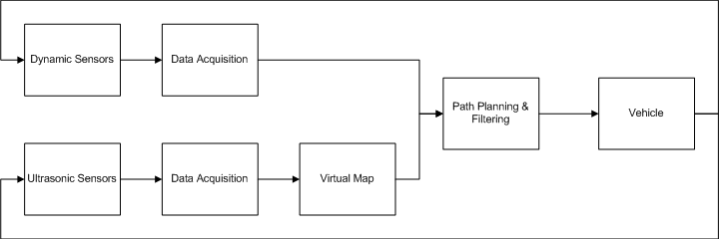

**On Board CPU**

**Sensors**

Figure . Rapidly-exploring Random Tree proposed software diagram, split into general task categories

The proposed software model can be broken down into three main process categories. From the ultrasonic and dynamic model sensors, data acquisition processes receive the data and store it for future use by the data visualization module. The data visualization module processes the acquired data and produces a virtual map of the environment along with a dynamic model of the vehicle. The virtual map is then passed to the path-planning module that uses the Rapidly-exploring Random Tree algorithm to generate feasible paths. The paths are then filtered according to the boundary conditions of the vehicle’s dynamic model to remove potentially dangerous paths. Finally, the feasibly safe paths are translated into vehicle control directives including steering angle, speed reduction rates, and braking forces.

## 4.2 Selection of Sensors

To map the environment and detect possible collision threats, system inputs are required. We concluded that there are three ways of going about this: simulated input, sensors on the track, or sensors on the vehicle.

### 4.2.1 Simulated Sensors

Using simulation software commercially available, crash avoidance systems will have the ability to pre-locate obstacles. This software would simplify the test scenario and place more emphasis on the detection and avoidance software. However, the test vehicle would be limited to predefined scenarios. Alternatively, the obstacles chosen could be pre-programmed into the crash avoidance system. The size of the obstacle and the location with respect to the test vehicle could be hard-coded into the crash avoidance system that would be retrieved when an external trigger was pressed to activate the obstacle. The velocity of the obstacle would also be programmed allowing the system to calculate the obstacles position and rate of motion at all times.

### 4.2.2 Track-based Sensors

Setting up sensors on the track could prove to be another way to detect obstacles. This method has several advantages over sensors on the vehicle. There are several track-based sensing methods. One method is a pressure sensitive track that detects pressure fluctuations from contact with obstacles. The main disadvantage is the excessive cost for the sensor material. To provide a random environment for the test vehicle to run, the obstacles would need to be placed at random along the track. For this reason, the entire track would require pressure sensitive material to detect the obstacle at any and all locations. Alternatively, a radar sensor at the end of the track could provide absolute location data of the obstacle and the test vehicle. The RADAR sensor is likely what would be used on an actual vehicle and could demonstrate that our algorithm works with full-scale equipment. However, depending on the size of the obstacle being deployed, the test vehicle could be blocked from the sensor’s view, resulting in an absence of position data for the vehicle. Two RADAR sensors can be deployed on each side of the track. However, this method increases the cost of materials and does not remedy the possible blindness of the sensor(s).

### 4.2.3 Vehicle-mounted Sensors

Mounting sensors on the vehicle allows increased resolution for environment mapping. With vehicle mounted sensors we can detect new obstacles with readings relative to the vehicle. However, the vehicle will require more robust protection for this equipment. By mounting the sensors on the vehicle, the system can be deployed in various environments with minimal configuration. The vehicle can be moved to different environments without relocating track sensors.

### 4.2.4 Sensor Position Selection

To facilitate focus on the path planning algorithm and filtering, it was decided to place sensors on the track. The track-based sensors will be places together with the obstacle. The decision matrix in Table the available sensors were compared based on their capability to meet the range, resolution, size, and cost requirements.

Table 4.2. Sensor decision matrix that best fits the proof of concept

|  |  |  |  |  |  |  |
| --- | --- | --- | --- | --- | --- | --- |
|  | **Range** | **Resolution** | **Dimensions** | **Weight** | **Cost** | **Total** |
| Ultrasonic | 3 | 5 | 5 | 5 | 5 | 4.5 |
| RADAR | 5 | 1 | 3 | 3 | 3 | 3.0 |
| LiDAR | 5 | 3 | 1 | 1 | 1 | 2.4 |
| Magnetic Res. | 3 | 1 | 5 | 5 | 5 | 3.6 |
| Infrared | 3 | 3 | 5 | 5 | 5 | 4.0 |
| Camera | 2 | 3 | 3 | 3 | 3 | 2.5 |
| Tactile | 1 | 3 | 5 | 5 | 5 | 3.0 |
| Weight | 5 | 5 | 3 | 3 | 5 |  |

Based on the general specifications of our design, Ultrasonic sensors meet the requirements for our model. Ultrasonic sensors are small, work within a range of 6 to 254 inches and are inexpensive. We can also use documentation and source code from the Robo-Magellan project to help incorporate the sensors into our system, reducing cross sensor interference and erroneous readings.

It is important to note that current crash detection systems use more sophisticated sensor types such as cameras. However, based on unknown demonstration conditions, this design cannot rely on speculation as to available lighting conditions or space. The camera would require adequate lighting to detect contrast between the obstacle and the environment. In addition, sensors such as RADAR would need to be offset from the track to overcome the minimum distance dead zone. For these reasons, the ultrasonic sensors ability to work in any lighting conditions and at shorter ranges makes it the best choice.

Three ultrasonic sensors will be used. Two will be grouped with the obstacle on the track. On ultrasonic sensor will be placed on each side of the track, facing inward towards the obstacle. The distance reading from these two sensors will provide the obstacles location along the width of the track as well as the obstacles width. A third sensor will be placed at a set distance ahead of the obstacle to re-initialize the vehicles position based on the IMU and encoder readings. By re-initializing the vehicle’s position, a more accurate location of the obstacle to the vehicle can be determined. A fair amount of drift and slop in the vehicles position is expected by using the IMU and encoders to track position.

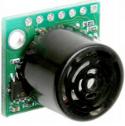

In selecting an ultrasonic sensor, the maximum sensing range of the ultrasonic sensor was partly based on the maximum length of the test track (25 ft). Although the system does not require environment data for the entire track, the further it can see ahead, the more time the system has to respond. In addition, a select number of obstacles contain small profiles when viewed by the ultrasonic sensor. Therefore, a sensor with a cone of influence cable of detecting smaller objects at closer ranges was desirable. Furthermore, the system setup was designed to run on serial communication between the sensors and microcontroller. Therefore, the sensors required a serial interface. The LV-MaxSonar-EZ2 ultrasonic sensor (Figure 1), sold by sparkfun.com was selected because of its cone of influence (Figure 10) and ability to detect smaller objects. The sensors detection range is from 6to 254 inches (approximately 21 ft) and contains a serial communication interface. In addition, the maximum reading rate is 20Hz which is sufficient based on the maximum allowable test vehicle speed of 4.5mph.

Figure 9. LV-MaxSonar-EZ2 ultrasonic sensor.

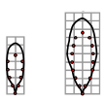

Figure . LV-MaxSonar-EZ2 cones of influence for a 1 inch dowel (left) and a 3.25 inch dowel (right).

The narrow cone for the smaller 1 inch dowel in Figure 10 is desirable for smaller objects. The detection of smaller objects is best with thinner cones. In addition, the LV-MaxSonar-EZ2 contains a narrow cone for larger diameter dowels resulting in a wider range of detectible object sizes.

## 4.3 Selection of Obstacles

To test and prove that our collision avoidance system works we need to test it under consistent conditions. We have come up with several obstacles that can be made to act predictably and consistently to debug the software and showcase the functionality of the avoidance system.

To select and design various obstacles for our vehicle to avoid it is necessary to consider the types of common hazards encountered in various settings. Pedestrians are a common hazard when driving. Pedestrians are small objects at long distances. While driving, a pedestrian may not be visible right away. In addition, pedestrians can be hidden from a drivers view by other cars, buildings, or poor weather conditions. Other obstacles can include wild animals that commonly interfere with highway driving For example, deer find their way onto roads in the line of traffic. Full-grown deer can cause serious injury to drivers and passengers if there were to be a collision. Based on the assumption that the deer will not move once caught in the headlights of a vehicle, it can be treated as a quasi-stationary obstacle. Aside from living obstacles, other vehicles can create hazards on the road. Cars stopped on the side of the road can block a clear path and cause an oncoming vehicle to swerve around to avoid a collision.

### 4.3.1 Stationary Obstacles

Stationary obstacles chosen include a stopped car and fallen utility pole. To model the stopped car, an R/C car shell will be used to simulate the size and profile of another vehicle. In addition, the pliable material of the shell body will reduce the damage to the test vehicle. To model the fallen utility pole a wooden dowel will be used. To ensure the obstacle can be detected by the sensors, one end will be propped to enlarge the profile and increase chances of detection. It is important to note that in some cases a crash is inevitable. In this case, maneuvers will be taken to reduce impact.

### 4.3.2 Moving Obstacles

To simulate cross traffic we plan on constructing a moving platform. The platform will be mounted on a set of wheels and will be pulled by a cord. The cord will lie low to the track so it does not interfere with the vehicle. Since it is not attached to the track a collision will not damage the track or the obstacle. We considered several other methods of moving an obstacle across the track. One idea was a ramp to roll the moving platform down and across the track. The main drawbacks of the ramp are that the obstacle will not move at a constant and controllable speed. Another idea was to have the moving platform be self-propelled. Having it be self-propelled would make the platform more susceptible to damage. We expect that it will be hit more than once by our vehicle and want to avoid performing excessive repairs. A simple sketch of the platform is shown in Figure 11.

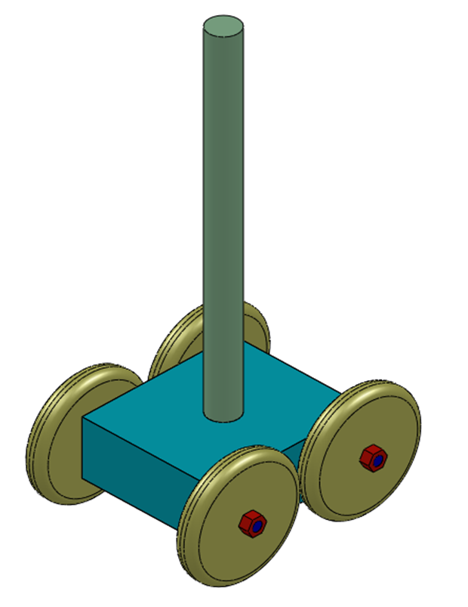

Figure 11. Computer sketch of mobile platform for pedestrian and cross-traffic vehicle obstacles

.

## 4.4 Selection of Radio Controlled Car

In selecting an R/C car to test our collision avoidance system we have a choice of two types of vehicles, gas or electric. Gas powered R/C cars travel much faster than what we require and produce exhaust fumes. In contrast, an electric car uses a reusable energy source—rechargeable batteries—without producing harmful fumes. In addition, the gas powered motor produces a loud idle noise and increases in decibels during runtime.

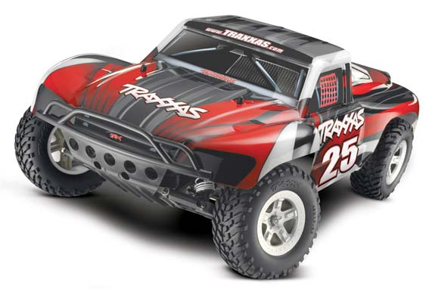In addition to the R/C vehicle’s fuel type, the chassis was selected. There are two types of chassis; car and truck. The car chassis sits low to the ground and has stiff suspension for tighter handling. During the demonstration of the crash avoidance system, tight maneuvering may be encountered. In this situation, it should be shown that the vehicle will roll without the avoidance system enabled. For this reason, the lower chassis, producing a lower center of gravity, would be increasingly difficult to roll. In addition, the stiffer suspension would keep the vehicle on the track during sharp turns. The truck chassis, however, contained soft suspension and a higher center of gravity. The higher center of gravity would reduce the efforts needed to roll the vehicle. In addition, the softer suspension would allow the trucks weight to shift more during sharp turns, assisting in rolling the vehicle over. Of the two vehicle types, the R/C truck was selected for its unstable properties and ease of rolling. Because the truck will be rolled, a roll cage will be added on to protect fragile hardware such as the IMU and servos. The R/C truck selected was the Traxxas Slash truck (Figure 12) from Atascadero Hobby Shop. This truck was selected because of its scale (1:10) and the availability of spare parts and support. In addition, the particular truck model had a roll cage available for purchase (Figure 13).

Figure . Traxxas Slash 2WD Ready-to-Run battery R/C truck.

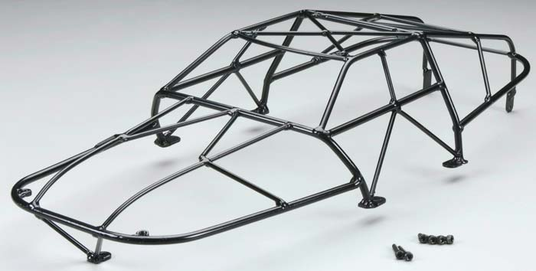

Figure . Traxxas Slash R/C truck roll cage.

By purchasing the roll cage, the amount of peripheral work can be cut down leaving more time spent on the path planning software development. In addition, the manufacturer has already dedicated time researching and developing a product that is capable of protecting the innards of the R/C truck.

## 4.5 Selection of the Test Track

The test track will be constructed with 1/10th scale dimensioning. Based on standard California highway standards; the track will be 4 feet wide by 25 feet long. Materials researched are enumerated in Table 0.1.

Table 0.1.3. Test track material decision matrix

|  |  |  |  |  |
| --- | --- | --- | --- | --- |
|  | **Weight** | **Durability** | **Cost** | **Total** |
| Dry-wall Compound | 5 | 1 | 1 | 2.54 |
| Shingles | 1 | 5 | 1 | 2.54 |
| Tar Paper | 5 | 5 | 3 | 4.54s |
| Weight | 5 | 5 | 3 |  |

Tar paper, used under roofing shingles, was selected for its light weight and durable characteristics. Because the concept considers a track up to 25 feet, portability and mobility are valid concerns. In addition, storage is a concern for such a large model. Furthermore, the weight of the material will reduce shipping cost, should this design be selected as a North American representative during the ESV conference. The use of the track will be introduced to non-hazardous or corrosive environment. Therefore, #15 grade paper will be sufficient.

# 5.0 Design Overview

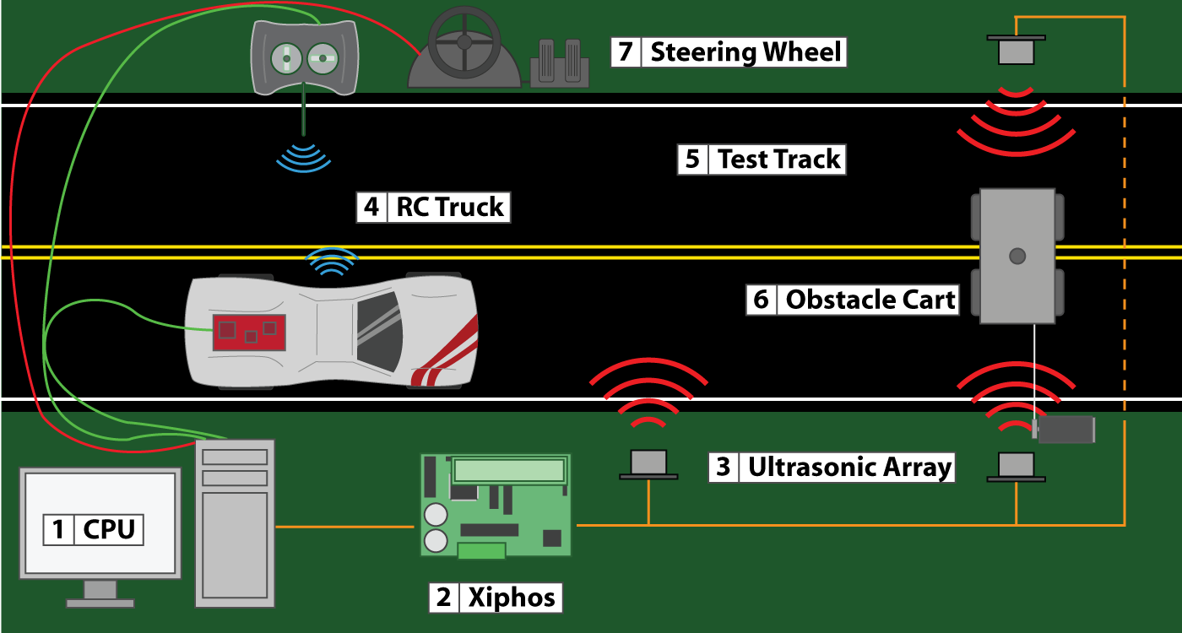

Figure . System setup overview

## 5.1 Concept Components

1. Computer executes the RRT algorithm and determines steering instructions. The computer will provide minimal data processing since the Xiphos board will handle the data from the ultrasonic sensors and the encoders. The IMU contains an onboard microprocessor that processes and smoothes its data before sending it to the computer. A USB steering wheel will be plugged into the computer so that the car can be manually driven. We chose to connect the steering wheel to the computer so that the computer can lock out user steering input when it begins autonomous navigation.

2. The R/C truck will have an IMU, RS232-to-Ethernet gateway, and four encoders mounted on its chassis. The IMU selected contains a serial output interface. Because long serial cables are difficult to find, Ethernet cable will provide lengths long enough to reach the central processors. The encoders will be wired to the Xiphos board for data processing through interrupt service routines on the Xiphos, We plan to have the encoders’ wires run alongside the Ethernet cable since we cannot hook up the encoders to the Ethernet wire.

3. Ultrasonic sensors will be linked together and fired in successive order to avoid misreading from another sensor ping. One sensor will be placed ahead of the obstacle to re-initialize the R/C trucks IMU position calculations. In addition, an infrared proximity sensor will be mounted in the same location to mark when the R/C truck reaches the zero mark. The ultrasonic sensors are connected to the Xiphos board through an UART (Tx/Rx) ports.

4. The Xiphos board will process the ultrasonic sensor data as well as the encoder data and send it to the PC through the RS232 serial communication protocol.

5. A moving obstacle will move between the ultrasonic sensors so that the obstacle’s position can be determined. It will be attached to a DC motor by a cable so it can be pulled across the track. The DC motor will then be wired to a potentiometer so that the voltage it receives can be varied, thus its speed varied. The cable will sit low to the ground to prevent interference with the trucks movement. In addition, there will be a falling dowel to mimic the action of a falling utility pole. It will have a servo attached to it to set it in motion.

6. The R/C remote control will be wired to the computer in order to send steering instructions to the truck through wireless transmission.

# 6.0 Final Design

## 6.1.0 Description & Layout

After presenting to the ESV Conference judges on March 29, 2011, the project was not selected for the 2011 ESV convention. Because of this turn of events, the focus of the project was revamped to accommodate a thesis student who would be using the platform for a stability control study. The steering wheel interface was removed from the project scope as well as the user interface within the TASS-Safe PreScan software. The remaining elements of the project included the Rapidly-exploring Random Tree algorithm, the path planner algorithm, the control of the vehicle through MATLAB, and the data acquisition of wheel speeds, vehicle accelerations, and vehicle tilt rates. The following diagram consists of the remaining elements for this project.

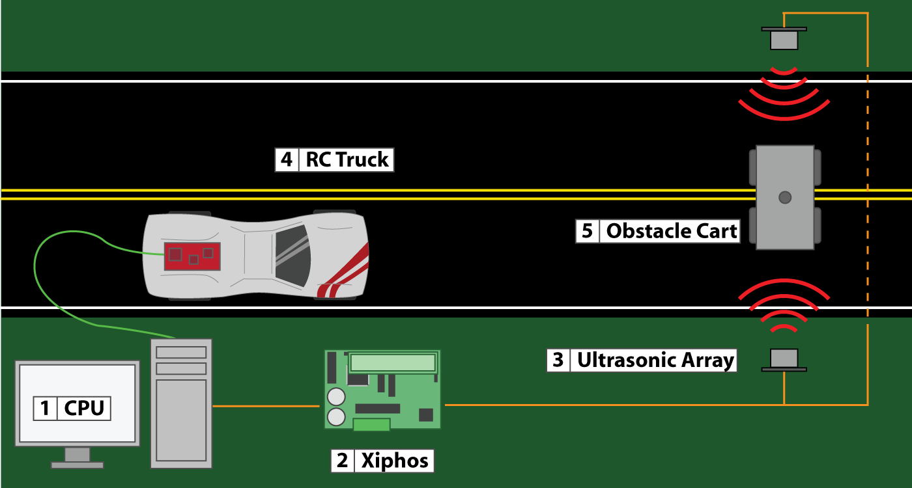

Figure 15. Reevaluated Project Layout

[1] CPU – The main central processing unit runs MATLAB that contains the RRT algorithm and path planner. The algorithms run in real-time as the obstacle position is updated and convert the selected path to vehicle steering and throttle commands.

[2] Xiphos – The Xiphos microcontroller board is responsible for collecting the obstacle’s position along the track and the obstacle’s width. By using a dedicated microcontroller to track the obstacle, additional sensors may be added without stealing valuable processor power from the main algorithms.

[3] Ultrasonic Array – The ultrasonic array tracks the obstacle along the width of the track. The ultrasonic array consists of two sensors across from one another on each along the width of the track. Each sensors waits for the other to receive their signal before triggering to avoid cross contamination. By running the Xiphos board at 16Mhz, accurate position and sizes can be determined using the ultrasonic sensors.

[4] R/C Truck – The R/C truck is an electric type hobby toy. The truck uses a hobby servo for steering control and a DC brushless motor for propulsion. The particular truck chosen was the Traxxas Slash 2WD truck because of its realistic suspension and high center of gravity. The driving motor and steering servo are controlled with an onboard microcontroller that reads in the commands from the main CPU.

[5] Obstacle Cart – The obstacle cart is a moving platform as a base for interchangeable objects. The obstacle cart moves manually on a linear path perpendicular to the test track. At this stage in the project, only cross traffic obstacles are considered.

## 6.2.0 UART Communication

The communication method used between the main computer and both the Xiphos (ultrasonic array) and the R/C truck’s onboard microcontroller was Universal Asynchronous Receiver/Transmitter (UART). Data transmitted through UART uses two separate lines to communicate, one for transmitting (Tx) data and one for receiving (Rx) data.

### 6.2.1 UART Basics

UART transmits one byte (8 bits or 1’s and 0’s) at a time. These bits get stored into a transmit or receive register until the register is full.

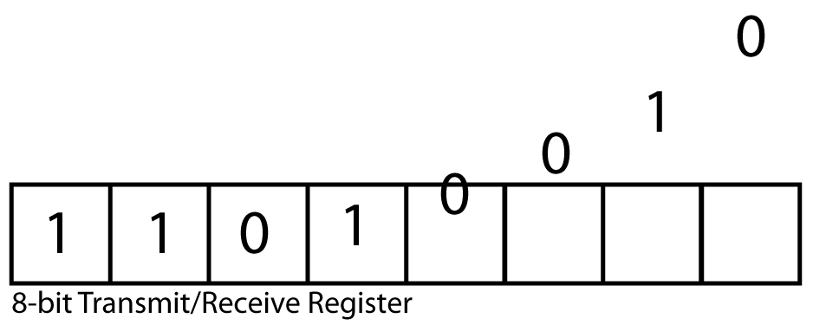

Figure 16. Data filling an 8-bit Transmit/Receive Register.

Once the register is full, a flag bit is set that alerts the main program that a full packet of data has been received or a full packet of data is ready to be sent. The purpose of waiting for a full register is to keep the data in discrete, recognizable chucks so it may be pieced back together predictably with little or no data corruption. In addition, because transmitting a full byte can take significant processing time, the flag ensure new data does not overwrite the register before the previous 8 bits are sent.

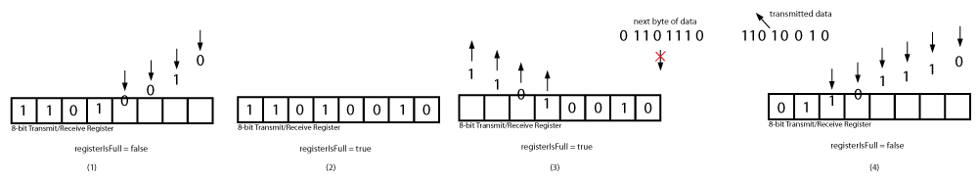

Figure 17. Data flow through UART transmit/receive registers.

Figure 17 presents the data basic data flow through a UART transmit/receive register. First a byte of information enters the register one bit at a time (Figure 17.1). The register is monitored to ensure data does not overflow past the 8 bits. Once the register is full, a flag (e.g. registerIsFull = true) is set alerting the main routine that a complete packet of data is ready to be sent or received (Figure 17.2). As the data from the register is being sent or received, the next byte cannot enter the register until it has been cleared and the “registerIsFull” flag has been unset (Figure 17.3). Once the register has been cleared of all previous bits, the byte of information can be captured (Figure 17.4).

### 6.2.2 UART Framing

In addition to the data bytes, UART uses addition bites to frame the data into a package. There are occasions where data being sent consists of less than 8 bits. Because data can be less than 8 bits it is necessary to indicate when a set of bits begins and ends. UART uses a start and stop bit to wrap the data bits.

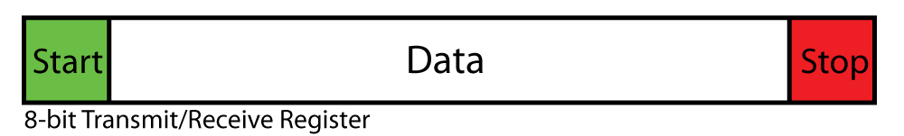

Figure 18. Data framed with a start and stop bit.

The start bit precedes the data bits and alerts the beginning of a new data package. Following the data is the stop bit that triggers the setting of the register is full flag.

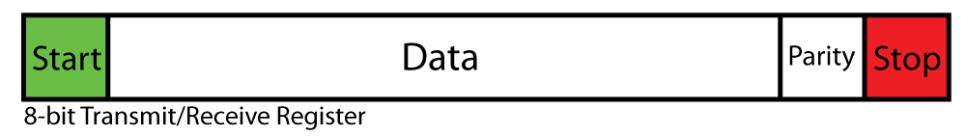

Figure 19. Parity bit set in a data package.

In addition to the start and stop bits is the parity bit. The parity bit acts as a data corruption check. Parity checks the number of bits that are set to one within the data. Even parity sets itself to one if the data contains an odd number of bits that are set to one resulting in an even number of ones in the package. If the data is then received and an odd number of ones are read, the data is considered corrupt. Similarly, odd parity keeps an odd number of ones in each data package and can be considered corrupt if once transmitted has an even number of ones.

## 6.3.0 R/C Truck Onboard Microcontroller

The R/C truck uses an onboard microcontroller to actuate the steering servo and driving DC motor. The microcontroller reads in steering and throttle control instructions sent by the central processing computer and adjusts the vehicle’s state accordingly. The onboard microcontroller provides more control than the remote control packaged with the truck.

### 6.3.1 dsPIC33FJ64MC202

The microcontroller used on the R/C truck is the Microchip dsPIC33FJ64MC202. This particular microcontroller contains an internal oscillator crystal is capable of running at 80MHz. This crash avoidance system requires tracking individual wheel speeds, accelerations, roll, pitch, and yaw. In addition to monitoring the dynamic state of the vehicle, the microcontroller needed to read in steering and throttle commands from the main computer and adjust the servo and DC motor accordingly. Because the microcontroller would have many peripherals to monitor, a microcontroller with a fast clock speed was required.

In addition, to monitor the wheel speeds encoders were used. To monitor wheel encoders interrupts are fairly common. Using four wheel encoders would require using four interrupt service routines which, at high speeds would slow down the main program. The dsPIC33F also includes two built-in quadrature encoder modules that are capable of monitoring up to two channel encoders plus an index channel. The quadrature encoder modules allow monitoring of encoders without interrupting the main program. By using the quadrature encoder modules the encoder data can be requested at the leisure of the program without worry of misreads.

The dsPIC33F also contains two UART modules. Both modules were used to communicate between the main central processer and the IMU. The central processor sends the steering and throttle commands via UART to the dsPIC33F. From there, the dsPIC33F converts the command to a pulse width value corresponding to the desired speed or steering angle. The second UART communicates to the IMU. The IMU monitors the accelerations, roll, pitch, and yaw rates and sends the information in successive order through the UART communication lines back to the dsPIC33F.

Further more, to control the R/C truck, it was necessary to send a pulse width signal to the steering servo and motor controller. The dsPIC33F contains three high voltage and three low voltage pulse width pins that are capable of driving the motor and servos.

The dsPIC33F was chosen because it contained a number of important peripherals built into the microcontroller. The modules used to build the onboard microcontroller system could have been purchased separately and connected other microcontrollers. However, the dsPIC33F came in a single, less complex, package. The benefit to using this particular chip was the reduction in electronic knowledge required to connect necessary peripherals.

### 6.3.2 Quadrature Encoder Interface (QEI)

Quadrature encoder interface (QEI) allows a program to keep track of encoder counts without disturbing the main program routine. At 80MHz and low speeds, tracking four encoders based on hardware interrupts are not a problem. However, when wheel speeds and encoder resolution increases, it becomes increasingly difficult for a program to keep an accurate count of the encoder ticks. To remedy this situation, two of the four encoders were connected to the dsPIC33F’s quadrature encoder modules built into the chip. These modules also run on interrupts but are separated from the main controller.

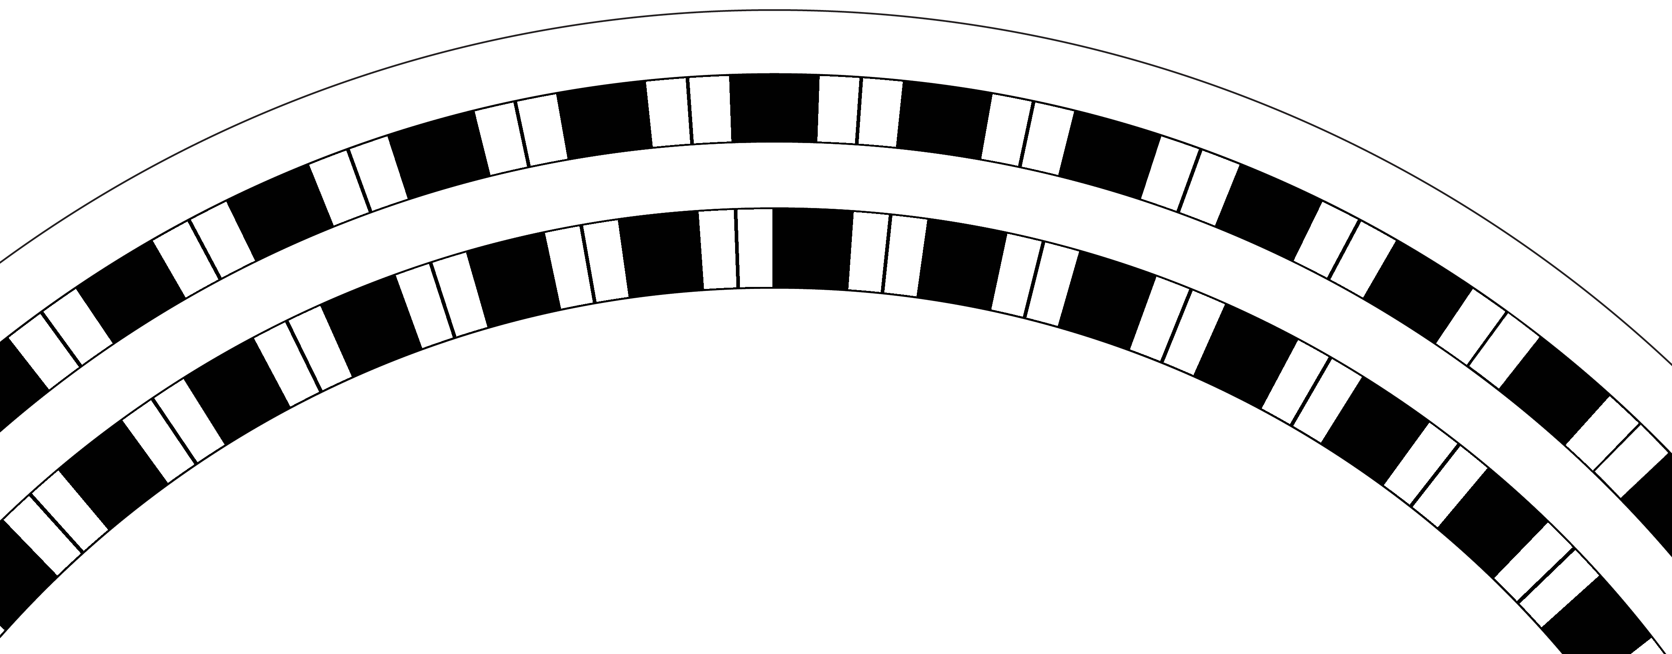

Figure 20. Two channel encoder disk.

The piece of a two channel encoder disk (figure 20) presents and example of the resolution encoders can have. The more ticks an encoder has, the more interrupts it will generate as the wheel spins faster. An increased number of interrupts can quickly impede the main program routine. Figure 20 depicts a two channel encoder disk that can detect direction based on the pattern of bits and the order they are received.

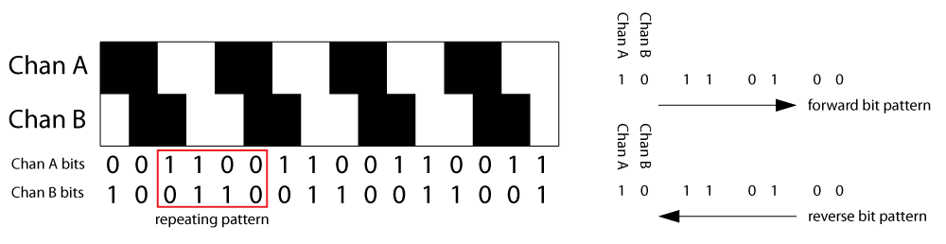

Figure 21. Quadrature encoder direction determination via 2 channel bit patterns.

Quadrature encoders have two separate encoder channels that are offset by one bit. There are two benefits to have one channel offset from another. The first benefit is that it is possible to determine the direction of motion. By monitoring the pattern of the pair of bits, one can determine whether the wheel is rotating clockwise or counter clockwise. In figure 21 lets assume that reading bits from left to right results in a forward motion of the encoder wheel. The bit pattern corresponding to this direction of motion is 10-11-01-00 repeatedly. This pattern of pairs is unique in this direction. Similarly, in the reverse direction, the pattern of pairs is opposite, 00-01-11-10.

Another advantage to offsetting the encoder markings by one bit is to eliminate middle state misreads. By nature of microcontrollers, changing a bit from a 1 to a 0 occurs faster than from a 0 to a 1. For example, if the current bit pair is 01 and the next bit pair is 10 both bits would need to change. The switch from 0 to 1 would take slightly longer than the switch for the other bit from 1 to 0 resulting in a temporary transition state of 00. This temporary state would result in a misread from the microcontroller. By offsetting the channels by one bit, no more than one bit changes at a time removing any chance of the temporary state.

For this crash avoidance system, the direction was always assumed to be forward. For this reason, two channel encoders were not used. However, two single channel encoders were still connected to the quadrature encoder modules. The modules do not count accurately without the second encoder. Therefore, a custom counter was added to the modules’ interrupts to count the ticks.

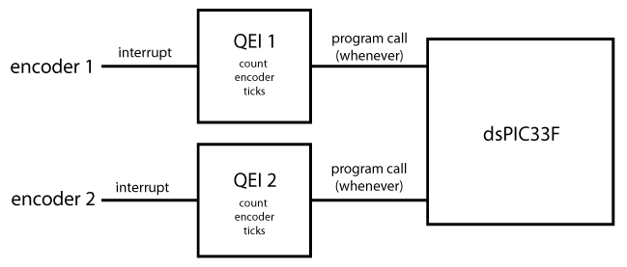

Figure 22. Data flow from encoders to dsPIC33F.

Figure 22 presents the data flow from the encoders to the onboard microcontroller. The encoders trigger interrupts on the quadrature encoder modules. Then the quadrature encoder modules keep track of the encoder count while the microcontroller continues to run the main program. When the main program is ready, it will retrieve the current counts from the modules.

# 7.0 Analysis Results

text here.

# 8.0 Cost Breakdown

The crash avoidance system was a combination of software and hardware. The cost to develop the physical test platform was as follows.

|  |  |  |  |  |
| --- | --- | --- | --- | --- |
| **Component** | **Qty.** | **Cost per Unit** | **Subtotal** | **Comments** |
| Traxxas Slash RC Truck | 1 |  |  |  |
| 6 DOF IMU | 1 |  |  |  |
| IR sensor (surface mount) | 4 |  |  |  |
| Slash Roll Cage | 1 |  |  |  |
| Pickit3 (programming) | 1 |  |  |  |
| Xiphos Development Board | 1 |  |  |  |
| Stripboard | 1 |  |  |  |
| Acrylic sheet | 1 |  |  |  |
|  |  |  |  |  |
|  |  |  |  |  |
|  |  |  |  |  |
|  |  |  |  |  |
|  |  |  |  |  |
|  |  |  |  |  |
|  |  | Total |  |  |

## 8.1.0 Materials, Geometry, Component Selection

text here.

# 6.0 Special Instructions

## 6.1 Hardware Protection

The IMU and batteries will be mounted on top of the frame of the truck using a bracket.  To protect these components when the car is rolled over, a roll cage will be placed over the frame.  This roll cage is pre-manufactured specifically for the Traxxas model of R/C truck and will require no special modifications to attach to the frame.  In the future this roll cage could also be used to mount sensors or other components.

## 6.2 Vehicle Dynamics Modifications

Several modifications must be made in order to change the vehicle’s dynamics, allowing it to roll over. The suspension will be stiffened by replacing the springs using off-the-shelf springs. The wheels also will affect the truck’s dynamics. If available, smaller wheels can be purchased, otherwise the existing wheels can be hardened by replacing their foam filling with a sturdier material.

## 6.3 Encoder Construction

Tachometers are constructed with two basic components; an encoder wheel attached to the axis of rotation, and a sensor to read the ticks of the wheel as it spins. An image of the encoder wheel will be created using encoder design software by Scott Boskovich. This image can be transferred to an Adobe Illustrator file and passed to the laser cutter, which will use the image to precisely create the disks from acrylic. These can then be mounted directly on the wheel axles. The Opto IR sensors will be mounted over these wheels on the frame of the truck, and will be connected to the tether between the truck and the PC.

## 6.4 Steering Wheel Interface

The R/C controller includes a steering wheel which is connected to a potentiometer.  When the wheel is turned it creates a variable voltage signal which is interpreted by a micro-controller and then sent to the truck via radio waves.  Because we are using a steering wheel attachment through the PC, the potentiometer can be bypassed and the analog signal passed directly from the PC.

# 7.0 Repairs

## 7.1 Basic Vehicle Repairs

Since our RC truck will be colliding with objects and rolling over during our testing phase damage to the truck will be inevitable.   We predict that much of this damage will occur to the RC shells of both the truck and moving obstacle.  We plan to mend small cracks during testing with tape and/or epoxy. Once the damage becomes too extensive, we can purchase a new replacement shell.  If there is any serious damage to the other parts of the R/C truck, such as the wheels or bumper, then we can purchase replacement parts from the local hobby shop (Atascadero Hobby Shop).  We will also make sure that there are no frayed wires and that the wired connections remain secure.

# 8.0 Preliminary Plans

## 8.1 Construction

Construction will begin with the obstacles. The obstacles will be used for physical testing once the first release of software has been verified with no errors detrimental to the host vehicle. Concurrently, the track will be constructed but with less emphasis than the obstacles.

### 8.1.1 Utility Pole

The poles trunk will be formed from a wooden dowel. No other modifications are necessary to simulate a utility pole. Other details may be added but are not required.

### 8.1.2 Pedestrian

The pedestrian will be a store-bought figurine approximately 1/10th scale to match remote control vehicle size. The pedestrian will be attached to a platform connected to an inlayed track system. The track system will mimic railroad track sunken into the pavement. The pedestrian/platform will be attached to a conveyer system powered by a DC motor.

### 8.1.3 Cross Traffic (Vehicle)

The cross traffic vehicle will use the same track system as the pedestrian. The cross traffic vehicle will not be a full working R/C car. Instead, a plastic R/C car shell will be mounted to the platform system. The use of just the shell will reduce cost and obstacle triggering components.

### 8.1.4 Rear End (Vehicle)

The rear end vehicle will consist of a stationary R/C car body shell. Similar to the cross traffic vehicle, the inner workings of the R/C car are not necessary. This particular obstacle will be stationary and hand set to a position on the track.

### 8.1.5 Remote Control Vehicle (Host Vehicle)

Stock tires will be replaced with smaller substitutes purchased from a hobby shop. Steel weight strips will be cut and placed at the top of the vehicles cab to raise the center of gravity. In addition, a roll cage fit for the chosen remote control vehicle will be purchased to protect added system hardware. If no cage exists, a custom cage will be built to protect the avoidance system hardware. The frame material has yet to be decided.

## 8.2 Testing

Testing of the obstacles will ensure repeatable and predictable results. The goal is to actuate the obstacles randomly. However, predictable obstacles will facilitate testing and debugging of the crash avoidance system.

### 8.2.1 Utility Pole

The Utility pole will not require further testing. The pole’s fate is to lie across the test track.

### 8.2.2 Pedestrian

The pedestrians average travel rate across the road will be calculated through repeated time trials. These trials will provide an estimate for system reaction time in addition to feasible pedestrian crossing speeds. The motor speed will be calculated to determine reasonable pedestrian crossing speeds and timed to ensure consistent results. These trials will also determine the visibility of small hazards such as pedestrians.

### 8.2.3 Cross Traffic (Vehicle)

The cross traffic vehicle will be tested in a similar fashion to the pedestrian. The pedestrian and cross traffic vehicle use the same platform pulley system to guide the obstacle across the track.

### 8.2.4 Rear End (Vehicle)

The rear end vehicle will be placed at designated locations on the track. This obstacle does not move and, therefore, all attention can be on the system host vehicle.

### 8.2.5 Remote Control Vehicle (Host Vehicle)

Once obstacles have been verified to produce consistent results and the avoidance software has been debugged for any errors that may cause disabling harm to the host vehicle, testing will commence. The host vehicle will interact with one obstacle at a time to monitor and compare the results with predicted responses. The host vehicle will be driven at slow speeds—approximately two miles per hour—until the crash avoidance system responses are what was predicted. Once system response is verified, the host vehicle speeds will be increased until average driving speeds (at 1/10th scale) are reached. Once the avoidance system has been verified with each obstacle individually, testing with commence with all obstacles triggered randomly.

# 9.0 Management Plan

## 9.1 Project Schedule

For a more detailed project schedule, refer to complete management plan in Appendix D.

Table 0.1 presents the schedule for the remainder of this senior project series. The table does not present start dates for the tasks enumerated below. For specifics on each task, consult the complete management plan in Appendix D.

Table .. Projected project schedule for the remainder of this senior project series.

|  |  |  |
| --- | --- | --- |
| **Task** | **Priority** | **Deadline** |
| Apply to MESFAC | High | 02/03/11 |
| Order remaining parts | High | 02/04/11 |
| Install/Assess PreScan | High | 02/06/11 |
| Test Sensors | High | 02/18/11 |
| Obstacle/Track Construction | Medium | 02/18/11 |
| R/C Truck modification | Medium | 02/18/11 |
| Software (DAQ) | High | 02/25/11 |
| Software (RRT) | High | 03/04/11 |
| Software (Path Follower) | High | 03/04/11 |
| ESV Judge Review | High | 03/27/11 |
| Preliminary Testing of software w/ obstacles | Medium | 04/02/11 |
| ESV Safety Statistic (on-going) | High | 04/21/11 |
| Final Testing on software w/ obstacles | Medium | 04/29/11 |
| ESV Conference | High | 06/13/11 |

# 10.0 Work Cited

1. http://www-nrd.nhtsa.dot.gov/departments/nrd-30/ncsa/stsi/6_CA/2009/6_CA_2009.PDF, Traffic Safety Facts California, accessed 10-18-2010
2. http://dmv.ca.gov/pubs/newsrel/media_center/california_dmv_statistics.htm, California DMV Statistics, accessed 10-18-2010
3. *Yoshiaki Kuwata, Justin Teo, Gaston Fiore, Sertac Karaman, Emilio Frazzoli, Jonathan P. How,* Real-Time Motion Planning With Applications to Autonomous Urban Driving, IEEE Transactions on Control Systems Technology, vol. 17, no. 5, pp. 1105 - 1118, Sep. 2009.
4. *Yoshiaki Kuwata, Gaston A. Fiore, Justin Teo, Emilio Frazzoli, Jonathan P. How,* Motion Planning for Urban Driving using RRT, Proceedings of the IEEE/RSJ International Conference on Intelligent Robots and Systems, Nice, France, Sep. 2008, pp. 1681 - 1686.
5. *Haykin, Simon,* Neural Networks: A Comprehensive Foundation Second Edition, Prentice Hall, 1999.
6. http://www.mbusa.com/mercedes/innovation/advanced_technologies/overview, Mercedes-Benz, Advanced Technologies, accessed 10-22-2010
7. http://www.toyota.com/safety/smart-stop-technology/, Toyota, Toyota Safety, accessed 10-22-2010
8. http://www.acura.com/ActiveSafety.aspx, Acura Advance, Active Safety, accessed 10-22-2010
9. http://www.tass-safe.com/en/products/details/33, TASS Beyond Safe, What is Prescan?, accessed 11-24-2010
10. *Shahin, Mohamed A., Jaksa, Mark B., Maier, Holger R.,* Artificial Neural Network Applications in Geotechnical Engineering, Department of Civil and Environmental Engineering, Adelaide University, March 2001
11. *Blackwell, William J., Chen, Frederick W.,* Neural Network Applications in High-Resolution Atmospheric Remote Sensing, Lincoln Laboratory Journal, Vol. 15 No. 2 2005
12. http://www.nrl.navy.mil/media/news-releases/129-10r/, NRL Scientists Discover Radio Detection and Ranging, Parry, Dan, accessed 11-24-2010
13. http://www.tycoelectronics.com/aboutus/news/prodinnov.aspx?id=976, 24GHz Short-Range Sensors for Driving-Assist Systems, Tyco Electronics, accessed 11-24-2010
14. http://www.velodyne.com/lidar/hdldownloads/HDL-32E%20datasheet_web.pdf, High Definition LiDAR HDL-32E, Velodyne, accessed 11-24-2010
15. http://www.sparkfun.com/products/639, Ultrasonic Range Finder, Sparkfun Electronics, accessed 11-24-2010
16. Messori, Tyson, *Pre-Crash Ultrasonic Sensor Test Report*, California Polytechnic State University, San Luis Obispo, April 2006.
17. Y. Kuwata, J. Teo, S. Karaman, G. Fiore, E. Frazzoli, and J. P. How, “Motion planning in complex environments using closed-loop prediction,” in AIAA Guidance, Navigation and Control Conference and Exhibit, Honolulu, HI, Aug. 2008, AIAA–2008–7166.
18. http://www.fhwa.dot.gov/publications/research/safety/09031/index.cfm, Safety Evaluation of Lane and Shoulder Width Combinations on Rural, Two-Lane, Undivided Roads, U.S. Department of Transportation Federal Highway Association, accessed 11-24-2010
19. http://world.honda.com/news/2009/4090219ITS-Safety-2010/, Honda to Exhibit its Latest Advanced Safety Vehicles, Honda, The Power of Dreams, accessed 01-15-2011.

# Appendix A: Quality Function Deployment

|  |  |  |  |  |  |  |  |  |  |  |  |  |  |  |  |  |  |  |
| --- | --- | --- | --- | --- | --- | --- | --- | --- | --- | --- | --- | --- | --- | --- | --- | --- | --- | --- |
|  |  | **Engineering Requirements** | | | | | | | | | | | | | | **Bchmk** | | |
|  |  | Weight | Number of Sensors (-) | Processing Time (ms) | Mass (kg) | Power (W) | Exposure (%) | Lifespan (yr) | Noise (dB) | Coverage (deg) | Installation Time (hr) | Maintenance Time (hr) | Durability (-) | Duty Cycle (hr) | Failsafe (-) |  |  |  |
| **Customer Requirements** | Minimize False Events | 9 | 9 | 9 |  | 1 |  |  |  | 9 |  |  |  |  |  |  |  |  |
| Minimize Rollover | 7 | 1 | 9 | 1 |  |  |  |  |  |  |  |  |  |  |  |  |  |
| Inexpensive | 8 | 9 | 3 | 9 | 9 | 3 | 3 |  | 9 | 9 | 9 | 3 | 3 |  |  |  |  |
| Provides Warning (visual/audible) | 5 | 3 | 9 |  |  |  |  |  | 1 |  |  |  |  |  |  |  |  |
| Low Power Consumption | 3 | 9 | 9 | 9 | 9 |  |  |  | 3 |  |  |  | 9 |  |  |  |  |
| Lightweight | 2 | 9 | 1 | 9 |  |  |  |  | 3 |  |  | 1 |  |  |  |  |  |
| Aesthetically Pleasing | 5 | 9 |  |  |  | 9 |  |  | 3 | 1 |  | 1 |  |  |  |  |  |
| Robust Detection | 8 | 9 | 3 |  |  |  |  |  | 9 |  |  |  |  |  |  |  |  |
| Low Maintenance | 5 | 9 |  |  |  | 1 | 3 |  | 3 | 3 | 9 | 3 | 3 |  |  |  |  |
| Long Lifespan | 6 | 3 |  |  | 1 |  | 9 |  |  |  |  | 3 |  |  |  |  |  |
| Durable | 4 |  |  | 1 |  | 3 | 3 |  |  | 1 |  | 9 |  |  |  |  |  |
| Panoramic View | 8 | 9 |  |  |  | 3 |  |  | 9 |  |  |  |  |  |  |  |  |
| Quiet | 7 | 3 |  |  | 1 |  |  | 9 |  |  |  |  |  |  |  |  |  |
| Small Components | 5 | 9 |  | 9 | 3 | 3 |  |  |  | 1 | 1 |  |  |  |  |  |  |
| Reduces Crash Events | 10 | 9 | 9 |  |  |  |  |  | 9 |  |  |  |  |  |  |  |  |
| Failsafe (regain manual control) | 8 |  |  |  |  |  |  |  |  |  |  |  |  | 9 |  |  |  |
|  | Units |  |  |  |  |  |  |  |  |  |  |  |  |  |  |  |  |  |
| Targets |  |  |  |  |  |  |  |  |  |  |  |  |  |  |  |  |  |
| **Bchmk** |  |  |  |  |  |  |  |  |  |  |  |  |  |  |  |  |  |  |
|  |  |  |  |  |  |  |  |  |  |  |  |  |  |  |  |  |  |
|  |  |  |  |  |  |  |  |  |  |  |  |  |  |  |  |  |  |

# Appendix B: Test Plan

|  |  |  |  |  |  |
| --- | --- | --- | --- | --- | --- |
| **Test Plan** | | | | | |
| **Item No.** | **Specification or Clause Reference** | **Test Description** | **Acceptance Criteria** | **Test Responsibility** | **Test Stage** |
| 1 | Total Apparatus Weight | Weigh components | Max - 100 lbs | Brian | CV |
| 2 | Physical Model Scale | Inspect box | 1:10 | Brian | CV |
| 3 | Track Size | Measure track size | 25 ft | Brian | CV |
| 4 | Safe Deceleration | Run vehicle and analyze sensor data | TBD | Josh | CV |
| 5 | Scaled Velocity | Run vehicle and analyze encoder data | 4.5 mph | Josh | CV |
| 6 | Detection-Reaction Delay | Analyze code using software timer | Max - .05 s | Gordon | CV |
| 7 | Steering Time Constant | Measure side movement by accelerometer output | .25 s | Brian | CV |
| 8 | Solving Time | Analyze code with software timer | .1 s | Gordon | CV |
| 9 | Avoidance Clearance | Record overhead view and measure clearance | Min - 2 in | Brian | CV |
| 10 | Roll Angle | Run vehicle and analyze sensor data | 30 deg | Josh | CV |
| 11 | Max Turn Angle | Run vehicle and analyze sensor data | TBD | Josh | CV |

# Appendix C: Parts List

|  |  |  |  |
| --- | --- | --- | --- |
| **Part** | **Supplier** | **Qty.** | **Cost per Unit (USD)** |
| 50:1 Gearmotor | polulu.com | 1 | $16.95 |
| Mounting Bracket | polulu.com | 1 | $4.99 |
| 32/7mm Fly wheel | polulu.com | 1 | $6.98 |
| 3-1/2” wheels (pack of 2) | horizonhobby.com | 2 | $9.29 |
| ¼” threaded rod | Home Depot | 1 | $1.00 |
| Traxxas Slash R/C Truck | Atascadero Hobby Shop | 1 | $239.99 |
| Roll Cage | Atascadero Hobby Shop | 1 | $34.99 |
| LV-Max Sonar EZ2 | Sparkfun.com | 3 | $27.95 |
| Xiphos Board | Cal Poly Robotics Club | 1 | $140.00 |
| Tar Paper (roll) | Home Depot | 1 | $25.00 |
| Atomic IMU | Sparkfun.com | 1 | $79.95 |
| Serial wire (6ft) | Sparkfun.com | 1 | $3.95 |
| Opto Encoder | Digikey.com | 4 | $31.85 |
| R/C Car Shell | Atascadero Hobby Shop | 1 | $35.00 |
| WIZnet Serial-to-Ethernet Gateway | Sparkfun.com | 1 | $29.95 |
| **TOTAL** | | | **$848.58** |

# Appendix D: Project Gantt Chart

# Appendix E: Ultrasonic Sample Calculation



# Appendix F: Xiphos Board

# Appendix G: LV MaxSonar EZ2

# Appendix H: WIZnet Gateway

# Appendix I: Opto Photo Interrupter

# Appendix J: Traxxas Slash Truck

# Appendix K: 6 DOF IMU